Table of Contents
Family Finding Response 2
Quick Add Contact 5
Document Upload 6

Family Finding Response

- If you are a Kinship Navigator Supervisor, navigate to Family finding tab in the dashboard and select the request that needs to be assigned and click on the ‘Assign /Transfer’ role.

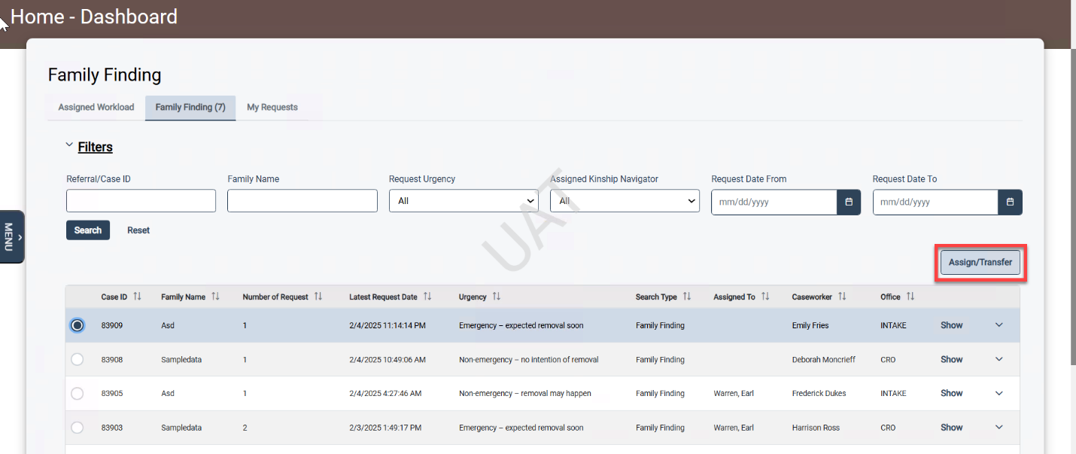
- The section to select the Kinship Navigator will open. Select one or more Kinship navigators who will be working on the request and click on the ‘Update Assignment’ button.
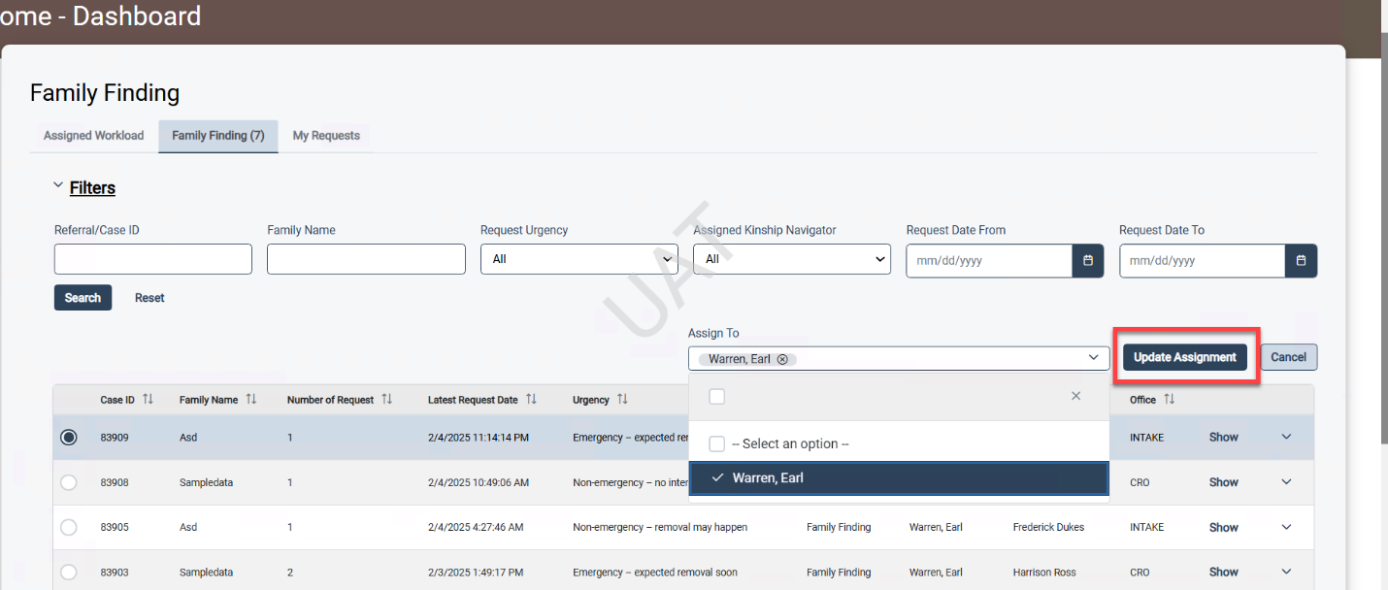

- If you are a Kinship Navigator, upon login you will by default see the Family Findings requests assigned to you. Click on the ‘Show’ for the request to work on.
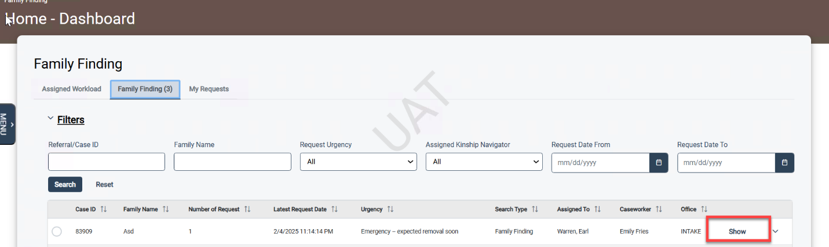

- On click of show the user will be navigated to the Family Finding Response screen -> Methods of identification tab. To document a new support effort, click on the ‘New’ button.
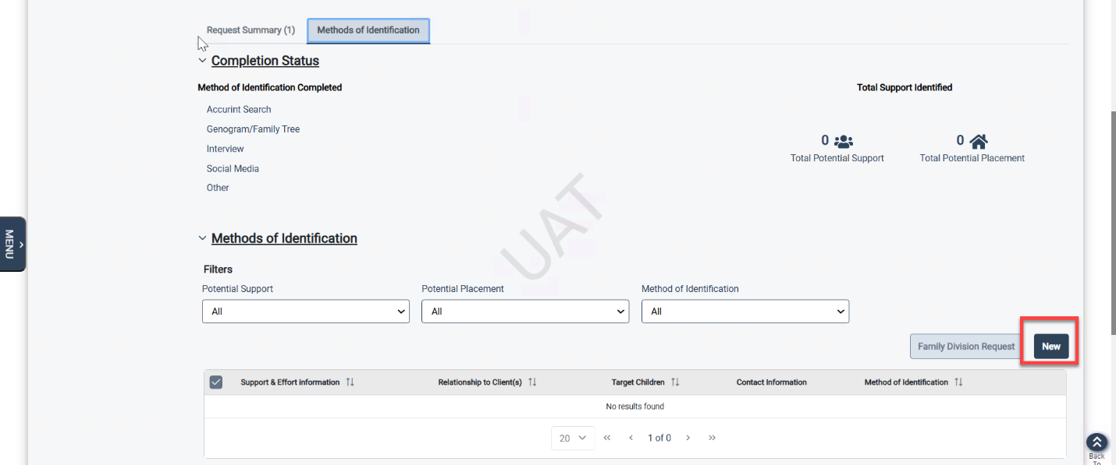

- On click of ‘New’ the New Potential support effort section gets displayed. Select the Target Child(ren) this support effort applies to. This field will populate the target children having an active Family Finding Request. Fill all the required fields including the methods of identification and save it. Please note that if any changes are made to the existing Support effort, the history for Contact Attempted, Contact Completed, Potential Support and Potential Placement and notes will be saved and displayed in the History grid.

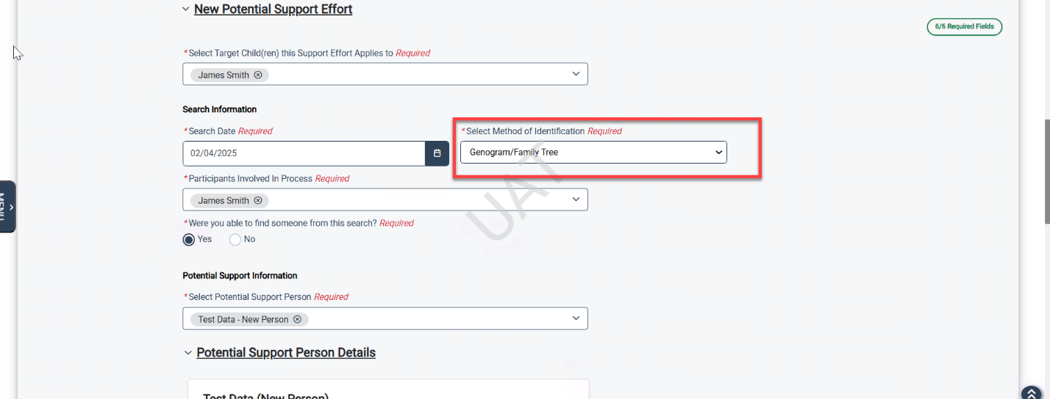

- After documenting all the support efforts and completing the response, click on the ‘Send Notification to Caseworker’ button to notify the assigned caseworker.
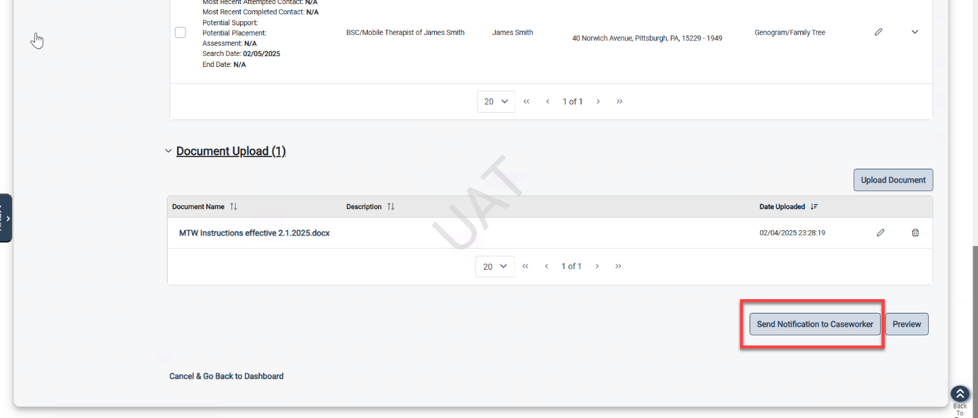

Quick Add Contact
- To add the Contact attempted/completed for the potential support, click on ‘Quick Add Contact’ button.
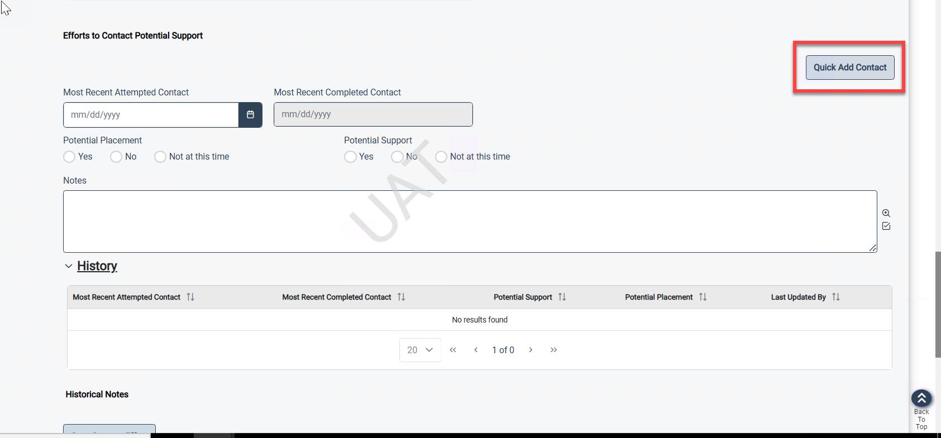
- On clicking the quick add contact button the pop up gets displayed. The user can fill in all the details and click on save.
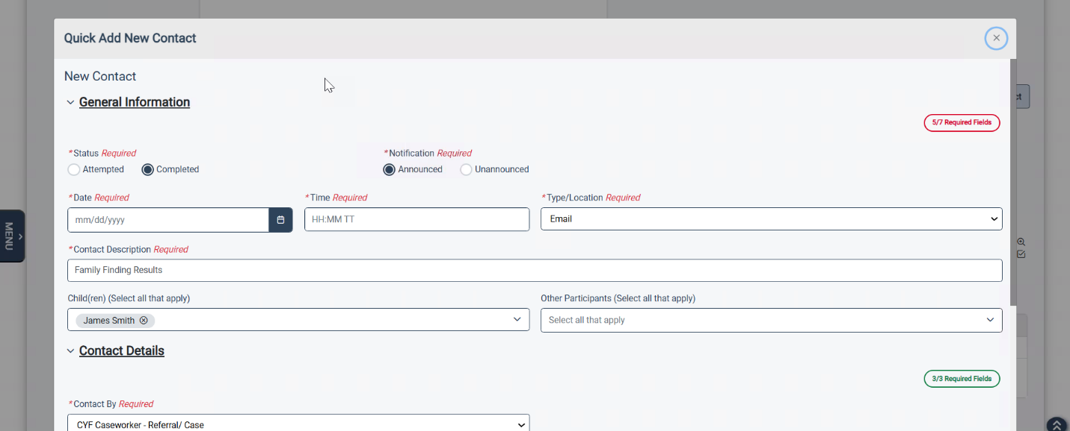

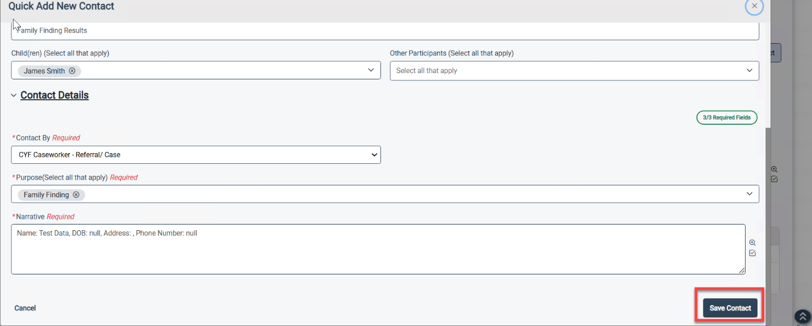

Document Upload
- To upload the documents, click on the upload documents button and select the documents that need to be uploaded.
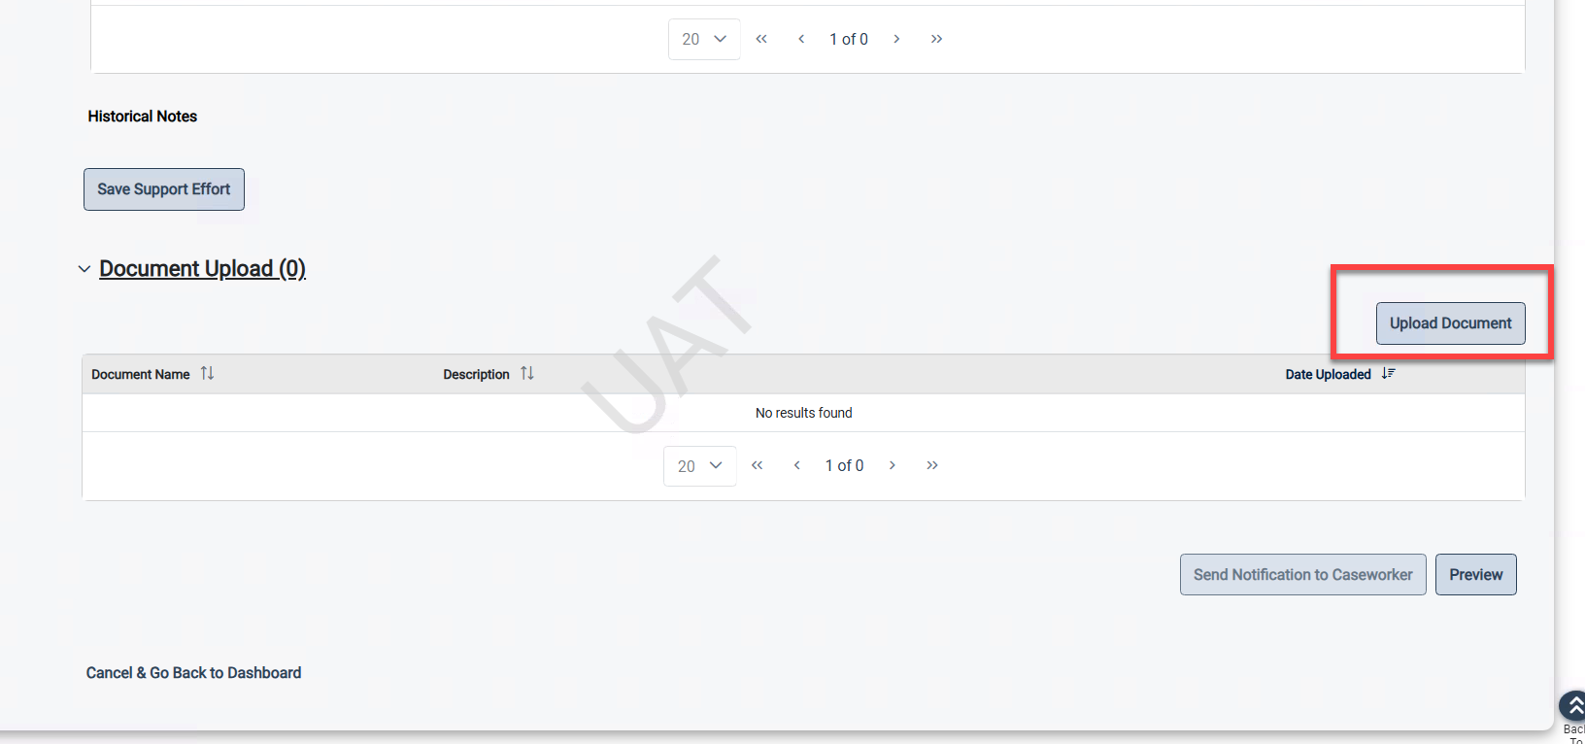

- Enter the description for the document. Click on the Upload button. Multiple documents can be uploaded at once.
